**Value Chain Analysis**

Report for Human Resources

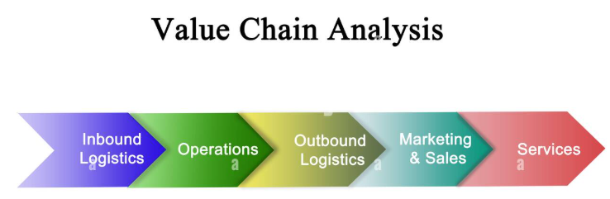

**Data Driven Decision Making**



**Data Dynamos**

For HR Data Analysis

**Value Chain Analysis Report for Human Resources**

**Introduction**

This report aims to analyze the HR value chain based on available data to understand how various factors impact recruitment, performance, training, and talent retention. The analysis relies on employee data, performance evaluations, satisfaction levels, and education levels, providing a comprehensive view of HR policy effectiveness.

**1. Talent Acquisition (Recruitment)**

* The data indicates variability in the distance from home, which may influence hiring decisions, as employees who live farther away may have a higher attrition rate.
* Some employees travel for business, requiring flexible recruitment policies to accommodate individuals who can adapt to travel demands.
* Recruitment strategies can be improved by analyzing demographic factors of talent and identifying the most effective sourcing channels.

**2. Performance Management**

* Employee performance has been assessed using performance rating data, reflecting the achievement of individual and organizational goals.
* Promotion analysis shows that some employees have spent many years in the same position without advancement, which may affect job motivation.
* Linking performance with motivation and training can help improve employee productivity and retention rates.

**3. Training & Development**

* Years of experience and education levels are linked to employee performance, indicating the need for targeted training programs to bridge skill gaps.
* Training programs can range from technical training and leadership skills to soft skills development.
* Assessing the effectiveness of training programs and their impact on performance helps prioritize investment in employee development.

**4. Talent Retention**

* Data shows that some employees leave due to factors such as salary and career opportunities, highlighting the need to review compensation and benefits policies.
* The relationship between job satisfaction and attrition requires further analysis, as psychological and organizational factors may play a role.
* Developing engagement strategies, such as offering a flexible work environment and financial and non-financial incentives, can help improve retention rates.

**5. Compensation & Benefits**

* Salaries and financial benefits play a crucial role in employee retention, as dissatisfied employees are more likely to leave the company.
* Overtime hours impact employee satisfaction and performance, requiring a balance in workload and fair compensation.
* Comparing compensation policies with market competitors ensures the company remains attractive in talent acquisition.

**6. Talent Management & Strategic Planning**

* The number of years with the current manager reflects the impact of leadership on job stability, as good management contributes to productivity and a positive work environment.
* Analysis highlights the need for career support programs and workplace enhancement by assessing leadership influence on team performance.
* Investing in internal talent development and succession planning helps strengthen organizational stability and prevent the loss of key talent.

**7. Recommendations**

1. Improve recruitment strategies based on distance and business travel analysis, with a focus on smart hiring techniques.
2. Enhance training programs based on employee performance and education levels, ensuring continuous learning opportunities.
3. Review promotion policies to guarantee career progression and better advancement opportunities within the organization.
4. Analyze the relationship between compensation and attrition to make informed financial decisions that enhance workforce stability.
5. Develop a supportive work environment to reduce attrition by improving workplace culture and strengthening communication between employees and management.
6. ****Assess the impact of leadership on job performance and provide development programs for managers to enhance effective leadership skills.

**Conclusion**

The HR value chain analysis reveals significant opportunities to enhance HR strategies by focusing on performance, training, and compensation to ensure organizational sustainability and achieve business goals. Investing in technology, continuous development, and talent retention strategies will have a positive long-term impact on company performance.



|  |
| --- |
| **Data Dynamos** |